**10 Query Database Apotek**

1. SELECT nama,keahlian FROM `apoteker` WHERE keahlian='pembuat obat'

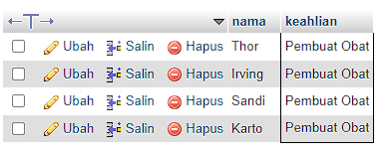

1. SELECT nama,keahlian FROM `apoteker`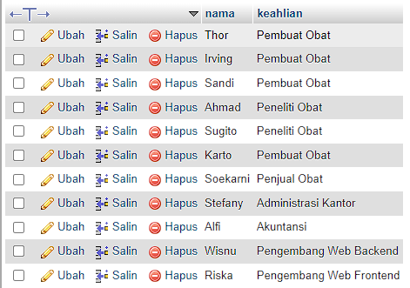
2. SELECT * FROM apoteker

WHERE nama='irving' AND keahlian='Pembuat obat';

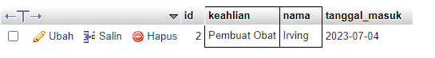

1. SELECT nama_obat,tanggal_kedaluarsa FROM `obat`

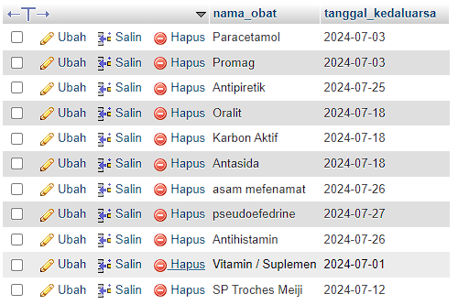

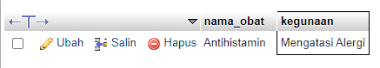

1. SELECT nama_obat,kegunaan FROM `obat` where kegunaan='Mengatasi Alergi'
2. SELECT nama_obat,kegunaan,apoteker_id FROM `obat` WHERE apoteker_id=1

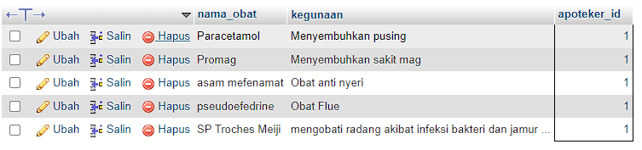

1. 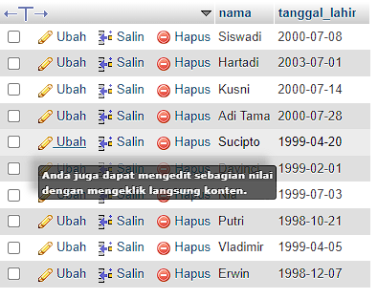SELECT nama,tanggal_lahir FROM `pasien`
2. 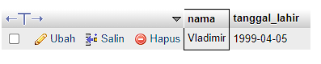SELECT nama,tanggal_lahir FROM `pasien` WHERE nama='vladimir'
3. 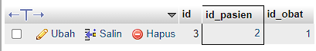SELECT * FROM `transaksi` WHERE id_pasien=2
4. 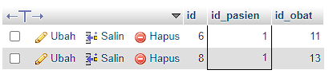SELECT * FROM `transaksi` WHERE id_pasien=1